

**The University of British Columbia Okanagan Campus Faculty of**

**Applied Science, School of Engineering**

**Course Title:**

**ENGR 544: Life Cycle Assessment and Management**

**Project Title:**

**A multi-objective optimization model for wooden chair closed-loop supply chain design**

**Instructor:**

**Dr. Babak Mohamadpour Tosarkani, Ph.D., P.Eng.**

**Prepared by:**

**Group-8**

Rajvansh Singh Gill

Darshan Paneerselvam

Syed Naveel Hussain

Ghulam Hussain

Kaimeng Du

Haniya Marium Anwar

**Table of Contents**

1. Introduction and problem definition 4

1.1. Problem Specification 5

2. Optimization Model 7

2.1. Assumptions 7

2.2. Sets 8

2.3. Parameters 8

2.4. Decision Variables 10

2.5. Objective Functions 10

2.6. Constraints 12

3. Solution Approach 14

4. Optimization Model Solution 15

4.1. Optimized values of objective functions 15

4.2. Selection of Supplier 16

4.3. Selection of Factory Location 16

4.4. Selection of Distributors 16

4.5. Selection of Recycling Units 17

5. Cost-benefit Analysis 18

6. Impact on Society and Environment 20

6.1. Environmental Impact 20

6.2. Societal Impact 21

7. Conclusions 21

8. References 23

**List of Tables**

Table 1 The optimal values of objective functions 15

Table 2 Selected Supplier, factory, Distributor, and Recycling Plants after Optimization 18

Table 3 Assumed annual values of Benefits from Selling Chairs and Stools 19

Table 4 calculations for selecting a suitable factory location using incremental benefit-cost ratio 19

**List of Figures**

Figure 1 A CLSC network for wooden chairs and stools, 5

Figure 2 Alternative locations for factory installation 6

Figure 3 Locations of Proposed Distributor Options 6

Figure 4 Proposed options for recycling plants 6

Figure 5 Model results for a selection of supplier 'BS' 16

Figure 6 Model results for selection of factory location 'BF' 16

Figure 7 Model results for the selection of Distributors 'BD' 17

Figure 8 Model results for selection of recycling units 'R' 17

Figure 9 Finalized locations of factory, distributors, markets, and recycling plants 18

# Introduction and problem definition

The furniture business is under increasing pressure to implement sustainable practices in the international market. Businesses are putting greater effort into creating closed-loop supply chains (CLSC) as environmental concerns gain traction to save waste and lower their carbon impact (Guide, 2009). This project aims to create a closed-loop supply chain for wooden chairs and stools optimized to ensure sustainable environmental practices and effective resource usage. Using multi-objective modeling, we attempt to balance the trade-offs between cutting expenses and CO2 emissions.

Reverse logistics is integrated with standard supply chain operations in the closed-loop supply chain framework, making it easier to return, recycle, and reuse products (Govinda, 2015). This all-encompassing strategy not only improves operational sustainability but also advances the circular economy's tenets, which call for materials to be continuously recycled back into the manufacturing process (Akdoğan, 2012). The project entails choosing the best manufacturers, distributors, suppliers, and recycling facilities to build a comprehensive and long-lasting supply chain network.

The primary objective of this project is to develop a multi-objective optimization model for a closed-loop supply chain network focused on wooden chairs and stools. The CLSC network is presented in Figure 1. The wood material “*Usfw* “required for product manufacturing is shipped to factory “F” by the supplier “S”. After manufacturing at the factory, “*Wfdw*“ number of wooden products are shipped from factory “F” to distributors “D”. The distributors send “*Ydmw”* number of wooden products to markets *“M”.* After the use of products by consumers, the products “*Xmrw*” are returned to recycling centers “R”. Some of the products “*Vrfw*” will be recycled and sent back to the factory, while unrecoverable products “*Zrw*” are sent to the landfill site.

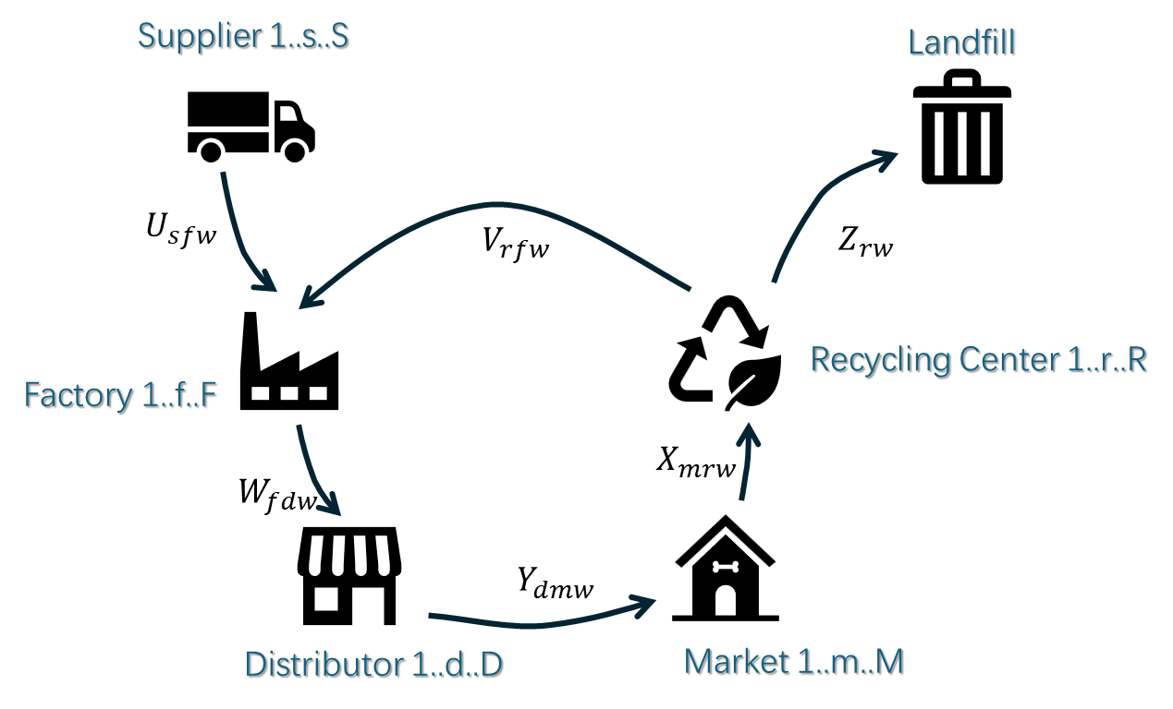

Figure 1 A CLSC network for wooden chairs and stools, where Usfw = Wood material to factor, Wfdw = Wood products to distributors, Ydmw = Products to market, Xmrw = products to recycling plant, Zrw = Unrecovered products to landfill, Vrfw = Recovered/recycled products to factory

## Problem Specification

The problem considered in this study is to select the most suitable location for installing the factory. We have three proposed locations as shown in Figure 2. The objective is to select the best sites for the factory to save emissions and transportation expenses while maintaining close access to suppliers and markets.

***Distributor Location:*** Choosing a distributor's location will help you effectively oversee how finished goods are delivered to clients and merchants. Five distributors are available (Figure 3) for model optimization to select the most suitable ones based on the selected factory location.

***Recycling Units:*** Recycling units should be set up to make it easier to collect, recycle, and repurpose wooden chairs and stools that are nearing the end of their useful lives. Four recycling plants are proposed for selecting the most suitable sites, based on the selected factory location, as shown in Figure 4.

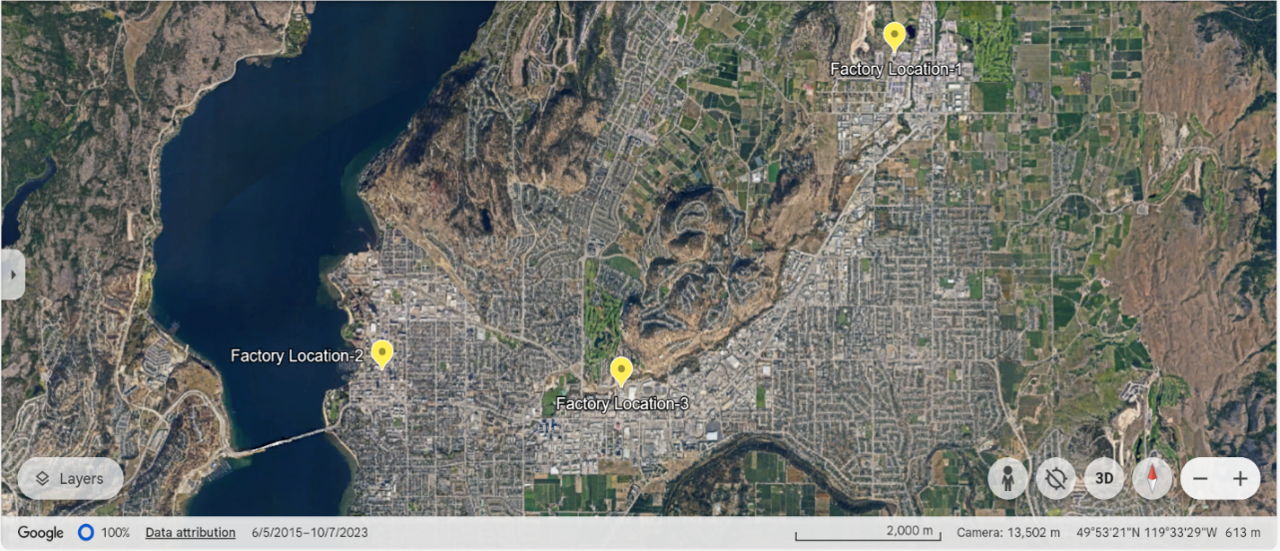

Figure 2 Alternative locations for factory installation

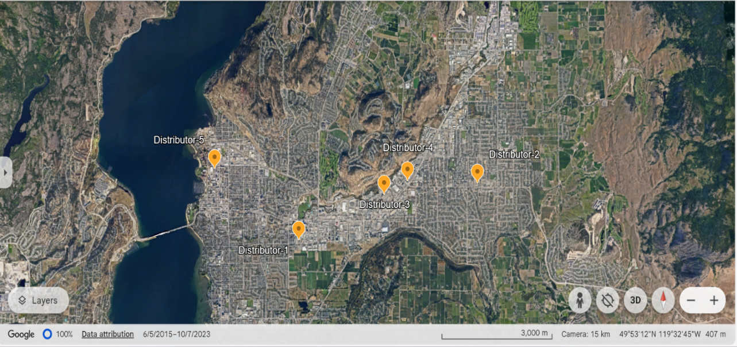

Figure 3 Locations of Proposed Distributor Options

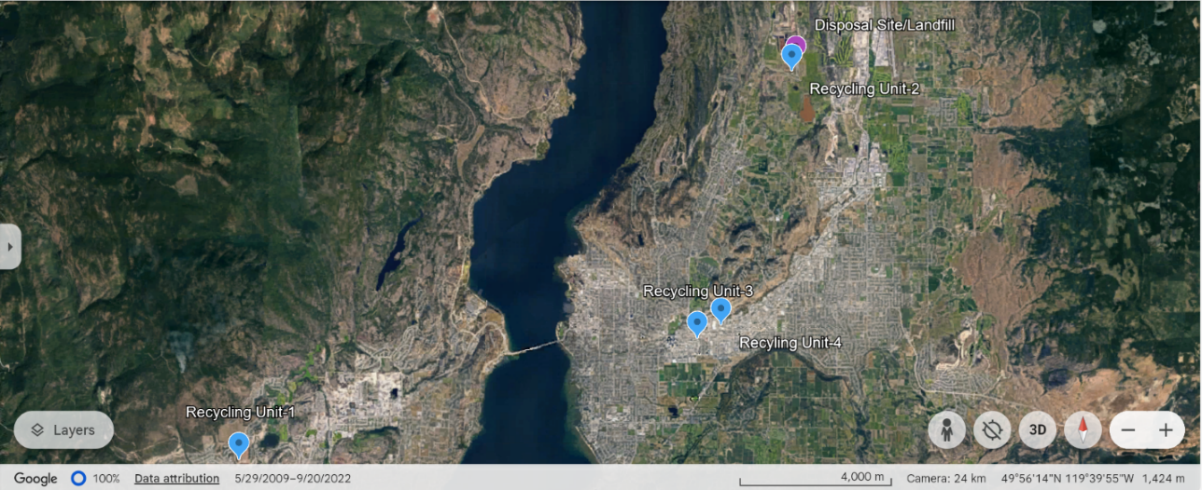

Figure 4 Proposed options for recycling plants

Using CPLEX software, we aim to develop a strong closed-loop supply chain model for the optimum selection of the above-mentioned parameters that strikes a balance between environmental responsibility and economic efficiency. Market locations are fixed therefore they are not considered for optimization in the model.

# Optimization Model

In this section, we formalize a CLSC using a multi-objective programming model. This model consists of two objective functions which consist of minimizing cost and also minimizing the CO2 emissions during the various life cycle stages of the chair. This multi-objective model can help policy-makers decide on supplier selection, facility locations, and installation of the recycling and landfill sites to promote cost savings techniques from the recycling of chairs. This model can also determine the number of products going to the landfill site along with the factory and the cost associated with the landfill of products. Assumptions, sets, parameters, and the decision variables used in mathematical programming are presented in the following sub-sections. Then, the studied problem is formalized as a multi-objective optimization model to determine the optimal values of decision variables.

## Assumptions

To formalize the studied CLSC network, we consider the following assumptions:

1. Market location is considered the region's center so part of the final delivery distance is ignored.
2. People return their chairs to the recycling center by the shortest route.
3. People use the same pickup truck to carry their chairs and stools home and return to the recycling center.
4. There is the use of the Ford F150 as a model since it is very common.
5. CO2 emissions in manufacturing and other processes are small and neglectable.
6. The recycle ratio is fixed and constant.
7. Glenmore landfill has all the capacity to handle all the disposals.
8. The demand and maximum capacity of all members active in the network are specified.
9. There are only 4 domestic regions as markets and all the sales to outside regions are not covered.
10. The inventory shortage is not allowed.
11. The introduced model is assumed to be a multi-product model.

## Sets

We have defined six sets for our optimization model. These sets are as follows: *W* = Set of our wooden products which are chairs and stools (*w $∈$* *W*), *w* = {*1,2*}; *S* = Set of suppliers (*s $∈$* *S*). We have two suppliers which are “Cedar Solutions” and “Valleyview Industries’ *s* = {*1,2*}; *F* = Set of factories (*f $∈$* *F*), f= {*1,2,3*}. There are three factories located on Lougheed Road, Ellis Street, and Hardy Street. *R* = Set of recycling centers (*r $∈$* *R*), *r* = {*1,2,3,4*}. There are four recycling centers located on Asquith Road, John Hindle Drive, Windsor Road, and Enterprise Way. *D* = Set of distributors (*d $∈$* *D*), *d* = {*1,2,3,4,5*}. Our five distributors are on Springfield Road, Highway 33 West, Enterprise Way, BC-97, and Ellis Street. *M* = Set of markets (*m $∈$* *M*), *m* = {*1,2,3,4*}. The four markets are located in Downtown, Glenmore, Lower Mission, and Rutland.

## Parameters

The parameters used in the CPLEX software to program the optimization model are defined as follows:

*As* = Cost of agreement (i.e., fixed costs) with supplier *s*

*Af* = Cost of agreement (i.e., fixed costs) with factory *f*

*Ad*= Cost of agreement (i.e., fixed costs) with distributor *d*

*Ar* = Cost of agreement (i.e., fixed costs) with recycling center *r*

*O1* = Transportation cost per km per item associated with truck 1

*O2* = Transportation cost pet km per item associated with truck 2

*Lsf* = Distance between locations *s* and *f*

*Lfd* = Distance between locations *f* and *d*

*Ldm* = Distance between locations *d* and *m*

*Lmr* = Distance between locations *m* and *r*

*Lr* = Distance between recycling center and landfill site

*Lrf* = Distance between locations *r* and *f*

*Pw* = Purchasing cost of wooden product *w* from suppliers

*Nw* = Recycling cost related to wooden product *w*

*Kw* = Amount of cost savings due to the recycling process of wooden product *w*

*Qw* = Disposal cost of wooden product *w*

*Dmw* = Demand of market *m* for wooden product *w*

*Rmw* = Return of wooden product *w* from market *m*

*Ssw* = Maximum capacity of supplier *s* for wooden product *w*

*Ffw* = Maximum capacity of factory *f* for wooden product *w*

*Ddw* = Maximum capacity of distributor *d* for wooden product *w*

*Rrw* = Maximum capacity of recycling center *r* for wooden product *w*

*T1* = Truck 1 capacity

*T2* = Truck 2 capacity

*E1* = Truck 1 carbon emissions per km

*E2* = Truck 2 carbon emissions per km

## Decision Variables

The decision variables used to address the vital information and come to a final decision are defined as follows:

*Usfw* = Number of wooden products shipped to factory *f* by supplier *s*

*Wfdw* = Number of wooden products shipped from factory *f* to distributor *d*

*Ydmw* = Number of wooden products sent from distributor *d* to market *m*

*Xmrw* = Number of wooden products returned from market *m* to recycling center *r*

*Zrw* = Number of unrecoverable wooden products *w* sent from recycling center to landfill site

*Vrfw* = Number of wooden products recycled by recycling center *r* for factory *f*

*Bs* = 1, if the supplier *s* is selected, 0, otherwise

*Bf* = 1, if the factory is located and set up at potential site *f*, 0, otherwise

*Bd* = 1, if the distributor is located and set up at potential site *d*, 0, otherwise

*Br* = 1, if the recycling center is located and set up at potential site *r*, 0, otherwise

## Objective Functions

The main objective of our study is to develop a closed-loop supply chain network by optimizing the supply chain. To make the best decision in selecting our suppliers, factories, distributors, recycling centers, and markets, the study defines two objective functions. The goal is to achieve the minimum cost and use the optimal transport mode which helps in the reduction of carbon emissions.

***Objective Function 1 (z1):***

The goal of objective function 1 is to minimize the costs related to this project.

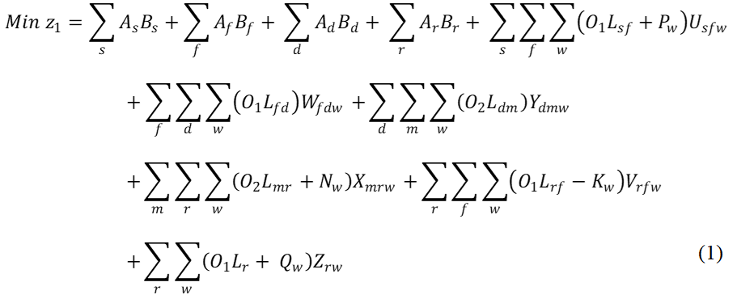The first four terms in Equation 1 are related to the cost of agreements (i.e., fixed costs) related to the supplier, factory, distributor, and recycling center. The fifth term relates to the transportation cost between the supplier and factory in addition to the purchasing cost of products from suppliers. The sixth and seventh terms relate to the transportation costs between the factory and distributor; and distributor and market, respectively. The eighth term relates to the transportation cost between the market and the recycling center in addition to the recycling cost. The ninth term is the transportation cost between the recycling center and factory in addition to the cost savings achieved by recycling. The final term is the transportation cost between the recycling center and landfill site in addition to the disposal cost.

***Objective Function 2 (z2):***

The goal of the second objective function is to minimize the carbon emissions released when transporting the products from one location to another.

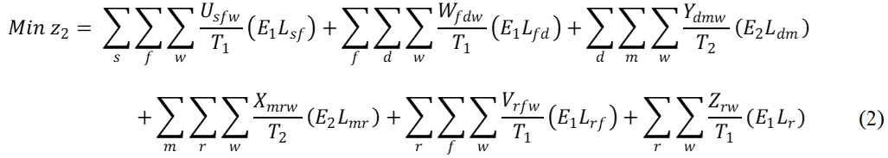

The first, second, fifth, and sixth terms of Equation 2 define the carbon emissions related to the transportation mode of using truck 1. On the other hand, the third and fourth terms of Equation 2 are associated with carbon emissions related to the transportation mode of using truck 2.

## Constraints

Equations 3 through 15 describe the various constraints of the multi-objective function introduced to address the CLSC design problem. These constraints include balance constraints, demand and return constraints, and capacity constraints.

***Balance Constraints***

$\sum_{d}{W_{fdw}= \sum_{s}{U_{sfw}+ \sum_{r}{V_{rfw}} ∀_{f, w} } }$ (3)

$\sum_{m}{X_{mrw}= \sum_{f}{V_{rfw}+ Z_{rw} ∀_{r, w} } }$ (4)

$\sum_{f}{W_{fdw}= \sum_{m}{Y_{dmw} { ∀}_{d, w} } }$ (5)

Equation 3 states that the output of the factory ($W_{fdw}$) should be equal to the inputs from the supplier ($U_{sfw}$) and the recycling center ($V_{rfw}$). Equation 4 states that the amount of input entering into the recycling center ($X_{mrw}$) should be equal to the output ($V_{rfw}$) and ($Z_{rw}$) leaving the recycling center. Equation 5 states that the input to the distributor ($W_{fdw}$) should be equal to its output ($Y_{dmw}$).

***Demand and Return Constraints***

$\sum_{d}{Y_{dmw}= D_{mw} { ∀}_{m, w}}$ (6)

$\sum_{r}{X_{mrw}= R_{mw} { ∀}_{m, w}}$ (7)

$\sum_{m}{α\left(X_{mrw}\right) ≤ Z_{rw} ∀_{r, w} }$ (8)

Equation 6 states that the input going into the market ($Y_{dmw}$) should be equal to the demand of the market ($D_{mw}$). Equation 7 states that output leaving the market ($X_{mrw}$) should be equal to the return of the wooden products from the market ($R_{mw}$). Equation 8 is related to the disposal rate. The percentage of input going to the recycling center ($X_{mrw}$) to be disposed of later should be less than or equal to the amount going to the landfill site ($Z_{rw}$)

***Capacity Constraints***

$\sum_{f}{U_{sfw} ≤ S_{sw}B_{s} ∀_{s, w } }$ (9)

$\sum_{d}{W_{fdw} ≤ F_{fw}B_{f} ∀_{f, w }}$ (10)

$\sum_{m}{Y_{dmw} ≤ D_{dw}B_{d} ∀_{d, w }}$ (11)

$\sum_{m}{X_{mrw} ≤ R_{rw}B_{r} { ∀}_{r, w }}$ (12)

Equations 9-12 represent that the production of wooden products should not exceed the maximum capacity of supplier *s*, factory *f*, distributor *d*, and recycling center *r*, respectively.

***Additional Constraints***

$\sum_{f}{B_{f}=1}$ ${ ∀}_{f}$ (13)

$B_{s}, B_{f}, B_{d}, B_{r} ∈\left\{0,1\right\} { ∀}_{f, s, d, r}$ (14)

$U_{sfw}, W_{fdw}, Y_{dmw}, X_{mrw}, Z_{rw} ≥0 { ∀}_{s, f, w,d,m,r }$ (15)

Equation 13 states that only one location can be selected for the factory. Equation 14 states that the variables for the selection of the supplier, factory, distributor, and recycling center can only be binary. Equation 15 states that the production quantities should be greater than or equal to 0. They cannot be a negative number.

# Solution Approach

We require a solution strategy to minimize the two objective functions at once because they contradict (z1: total cost and z2: CO2 emissions). The first objective function's dimension is also different from the other function. To solve the multi-objective optimization model, we employed the global criteria method. The corresponding carbon cost of CO2 emissions ($50 per ton) is represented by a new float in our model.

According to this method, the final objective function is formulated as follows:

$\min{Z= w_{1}(\frac{z_{1}-z_{1}^{*}}{z_{1}^{*}})+w_{2}(\frac{z_{2}-z_{2}^{*}}{z_{2}^{*}})}$ (16)

Where, z1* = Independent optimization result of z1

z2* = Independent optimization result of z2

Minimizing the overall relative deviation of each objective from its optimal values, which are reached by separate optimization, is the main aim of Equation 16. Based on the decision-makers’ desire, the weights of the first and second objective functions are represented by the symbols w1 and w2, respectively, in this equation. In this study, we have chosen the numbers w1=0.5 and w2=0.5 considering the objective functions' relative importance is equal.

# Optimization Model Solution

## Optimized values of objective functions

The solution is found by optimizing the two objective functions. The model is run on the CPLEX software to obtain the best results. The complete model is attached as Appendix 1. The optimum solution value for both objective functions i.e., z1 total cost and z2 carbon emissions is shown in Table 1.

**Table 1 The optimal values of objective functions**

|  |  |  |
| --- | --- | --- |
| **Optimization mode** | z1 | z2 |
| Independent optimization of z1 | 172595 | 5014 |
| Independent optimization of z2 | 208438 | 4529 |
| Simultaneous optimization (Z) | 173443 | 4534 |

The total cost that is reached when the model optimizes only for cost minimization (𝑧1) is 172595 units. 5014 units of CO2 are released as a result of this economical approach. This result suggests that reducing costs results in relatively high emissions, indicating a trade-off where cost-cutting strategies may entail fewer ecologically beneficial actions. 4529 units of CO2 are produced when the model only optimizes for minimizing CO2 emissions (z2). The greater overall cost of 208438 units is the result of this environmentally friendly option.

This result demonstrates that lowering CO2 emissions requires more money, most likely as a result of using more costly but sustainable products and procedures. The cost stays at 172595 units in the simultaneous optimization scenario—the same as the outcome of the independent cost optimization. At 226473 units, the CO2 emissions in this scenario are noticeably higher. Given that the CO2 emissions figure is disproportionately high in comparison to the other scenarios, this result is surprising and may indicate a problem or error in the optimization model.

## Selection of Supplier

As per the results of the model, shown in Figure 5, Supplier-2 i.e., Valley View Industries will be selected.

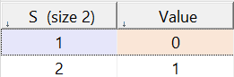

Figure 5 Model results for a selection of supplier 'BS'

## Selection of Factory Location

We have provided a model constraint to select only one factory location out of three available locations. As per the model results, location 3 i.e., 1505 Hardy Street should be selected.

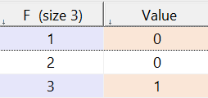

Figure 6 Model results for selection of factory location 'BF'

## Selection of Distributors

Four distributors are selected among the five options, while the distributor located at 2515 Enterprise Way is rejected as it doesn’t fit into the optimized solution for cost and carbon emissions.

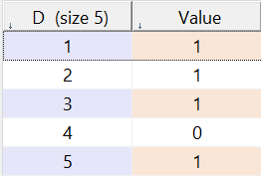

Figure 7 Model results for the selection of Distributors 'BD'

## Selection of Recycling Units

Recycling is a crucial component of the overall life cycle of the project as it provides a sustainable approach to our product. To maximize the recycling potential, four recycling units were proposed. Out of those, three have been selected by the model solution, rejecting the one located on the west side as it might have contributed to more transportation costs and associated CO2 emissions.

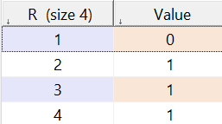

Figure 8 Model results for selection of recycling units 'R'

The selected options for the supplier, factory units, distributors, and recycling units have been shown in Table 2 (Highlighted in green).

**Table 2 Selected Supplier, factory, Distributor, and Recycling Plants after Optimization**

|  |  |  |  |  |
| --- | --- | --- | --- | --- |
| **Code** | **S Supplier** | **F Factory Location** | **D Distributor** | **R Recycle Center** |
| 1 | Cedar Solution | 210 Lougheed Road | 1650 Springfield Road | Westside |
| 2 | Valleyview | 1465 Ellis Street | 470 Highway #33 West | Glenmore Landfill |
| 3 |  | 1505 Hardy Street | 2515 Enterprise Way | Kelowna Recycling |
| 4 |  |  | 2514 BC-97 | Habitat for Humanity |
| 5 |  |  | 1264 Ellis St |  |

The locations of these finalized components are shown in Figure 9.

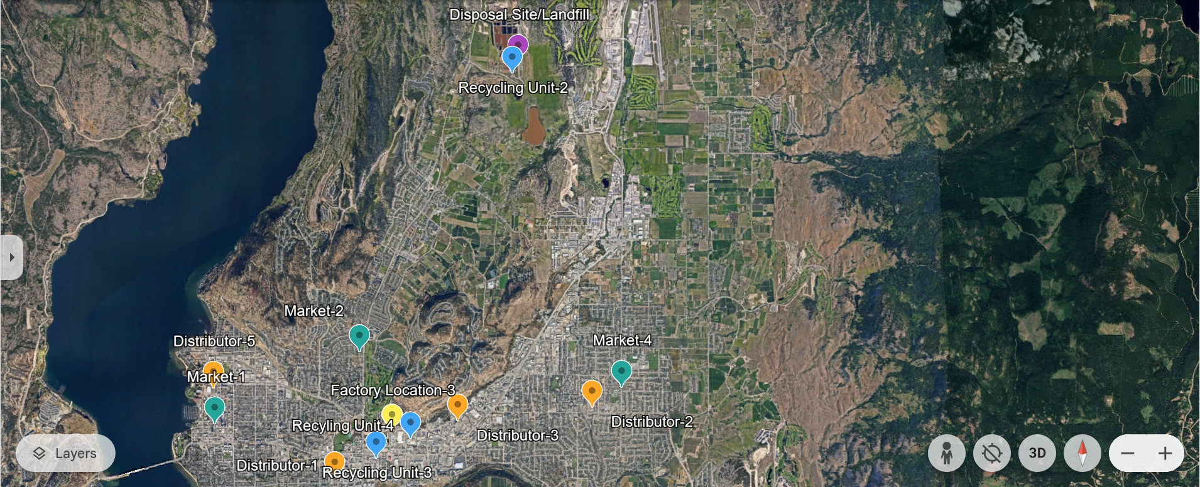

Figure 9 Finalized locations of factory, distributors, markets, and recycling plants

# Cost-benefit Analysis

To analyze the benefit-cost ratio, we assumed the benefit of selling chairs and stools at different markets as shown in Table 3.

**Table 3 Assumed annual values of Benefits from Selling Chairs and Stools**

|  |  |  |
| --- | --- | --- |
| **Markets** | **Chair (150 CAD per item)** | **Stool (30 CAD per item)** |
| Downtown | 300 | 300 |
| Glenmore | 200 | 200 |
| Mission | 200 | 400 |
| Rutland | 400 | 200 |
| Total | 1100 | 1100 |
| Total Benefit | 165000 | 33000 |
| Total Benefit (Chairs + Stools) | **198000 CAD** | |

For analyzing the best suitable factory location concerning cost, we have used multiple alternatives using incremental B/C Ratios. The calculations are presented in Table 4. Since we are assuming a year (12-month) lease period for the factory installation, we have converted all the costs to a monthly basis while calculating the B/C ratio.

**Table 4 Calculations for selecting a suitable factory location using incremental benefit-cost ratio**

|  |  |  |  |
| --- | --- | --- | --- |
| **Alternatives** | **Factory-1** | **Factory-2** | **Factory-3** |
| Capital Cost, CAD | 115000 | 115000 | 115000 |
| Monthly Cost (Rent +O&M), CAD/month | 6,684 | 4,882 | 4,800 |
| Benefits, CAD/month | 16500 | 16500 | 16500 |
|  |  |  |  |
| MW of total cost, CAD/month | 7048.28 | 5247.20 | 5164.36 |
| MW of benefits, CAD/month | 16500 | 16500 | 16500 |
|  |  |  |  |
| Reorder by increasing the cost | **Factory 3** | **Factory 2** | **Factory 1** |
| MW of total cost, CAD/month | 5164.36 | 5247.20 | 7048.28 |
| MW of benefits, CAD/month | 16500 | 16500 | 16500 |
| ΔC, CAD/month | 5164.4 | 82.8 | 1801.1 |
| ΔB, CAD/month | 16500 | 0 | 0 |
| ΔB/C | **3.19** | **0.00** | **0.00** |
| Increment justified | Yes | No | No |
| **Selection** | **Select Factory 3, it is incrementally justified** | | |

As per the results of ΔB/C in Table 4, Factory 1 and Factory 2 are not incrementally justified. Therefore, Factory 3 is selected. This result coincides with the optimization result of multi-objective modeling using CPLEX.

# Impact on Society and Environment

## Environmental Impact

We have optimized the system by considering CO2 emissions as one of the objective functions in the model. This implies that the optimum selection of choices was based on a sustainability approach. Likewise, recycling of wood has been incorporated for about 70% of the waste wood, which is a major sustainability factor. Recycling wood from chairs or stools can have significant environmental and societal impacts. In our project results, around 70% of the wood will be recycled after it has been used. It helps reduce the demand for new timber, which can lower the rate of deforestation. This is crucial for maintaining biodiversity and preserving habitats for various species. Assuming each chair or stool is made of 10 kg of wood (as defined in Project-1), recycling 910 units would save approximately 9,100 kg of wood from being wasted. This translates to a significant amount of carbon savings, considering the carbon sequestered in that wood. Additionally, trees absorb CO2, so conserving forests can help mitigate climate change.

Recycling 70% of wood means less material (around 30%) ending up in landfills, thereby reducing landfill use and the associated issues, such as methane emissions from decomposing wood. By recycling wood, we conserve natural resources. This includes not only the wood itself, but also the water and energy used in the process of growing, harvesting, and processing new timber. Reduced logging activities mean less soil erosion and water runoff, which can protect soil quality and water bodies from sedimentation and pollution.

## Societal Impact

Recycling industries can create jobs and stimulate economic activity. Recycling programs often involve community participation, raising awareness about sustainability, and encouraging more responsible consumption and waste management practices. Recycling initiatives can foster innovation in creating new products from recycled materials. Reducing landfill waste can lower the incidence of pollution-related health issues (respiratory issues and groundwater contamination) in communities near landfills.

# Conclusions

In this research, a multi-objective optimization model for designing a CLSC for ‘wooden chairs and stools’ has been introduced and implemented. The output of this model has identified the optimum locations of suppliers, factory units, distributors, and recycling plants. The outcome can help the decision-makers to easily make tactical decisions to select the most sustainable and economical options in the CLSC design problems. These decisions are made concerning the simultaneous optimization of two objective functions, including minimizing total cost and minimizing CO2 emissions. In our project, three recycling plants have been proposed to recycle as much wood as possible (70% of the total). The recycling practices opted for in this project and the overall optimized selection of facilities would have significant positive impacts on the environment and society including resource conservation, reducing deforestation, resource conservation, creation of jobs, awareness about sustainability, and engagement in recycling practices. The results of the model may vary based on applying different weights to the objective functions (cost and CO2 emissions in this case) which are usually defined by the company policies. Therefore, careful weighting is desired to create a balance for both the objective functions.

# References

Akdoğan, M. Ş., & Coşkun, A. (2012). Drivers of reverse logistics activities: an empirical investigation. Procedia-Social and Behavioral Sciences, 58, 1640-1649. <https://doi.org/10.1016/j.sbspro.2012.09.1130>

Dekker, R., Bloemhof, J., & Mallidis, I. (2012). Operations Research for green logistics–An overview of aspects, issues, contributions and challenges. European Journal of Operational Research, 219(3), 671-679. <https://doi.org/10.1016/j.ejor.2011.11.010>

Govindan, K., Soleimani, H., & Kannan, D. (2015). Reverse logistics and closed-loop supply chain: A comprehensive review to explore the future. European Journal of Operational Research, 240(3), 603-626. <https://doi.org/10.1016/j.ejor.2014.07.012>

Guide Jr, V. D. R., & Van Wassenhove, L. N. (2009). OR FORUM—The evolution of closed-loop supply chain research. Operations research, 57(1), 10-18. <https://doi.org/10.1287/opre.1080.0628>

Krikke, H. R., Le Blanc, I. J., & Van de Velde, S. (2004). Product modularity and the design of closed-loop supply chains. California Management Review, 46(2), 23-39. <https://doi.org/10.2307/41166208>

**Appendix-1**

/*********************************************

* OPL 22.1.1.0 Model

* Author: Group-8

* Creation Date: 2024 8 5 at 4:25:54

*********************************************/

range S= 1..2;//set of wood supplier

range F= 1..3;//set of factory location

range D= 1..5; //set of distributor

range M= 1..4; //set of markets

range R= 1..4;//set of recycling centers

range W= 1..2;//set of products

//Parameters

float AS[S]=[10000, 10000]; //cost of agreement (i.e., fixed-cost) with bottle producers

float AR[R]=[0.1, 0.1, 0.1, 0.1];//cost of agreement (i.e., fixed-cost) with recycling centers

//maximum capacity of wood producers Vernon, Kamloops

float CS[S][W]=[[6500,6500],[8000,8000]];

//purchasing cost from wood producers Vernon, Kamloops

float P[S][W]=[[35,10],[30,7]];

//maximum capacity of factory, 210 Lougheed Road (U), 1465 Ellis Street (D), 1505 Hardy Street(M)

float CF[F][W]=[[22*8*2*10, 22*8*4*10],[22*8*2*4, 22*8*4*4],[22*8*2*6, 22*8*4*6]];

//cost of agreement (i.e., fixed-cost) with factory location, 1 year rate+fixed equipment

float AF[F]=[42000+5000, 20500+5000, 19760+5000];

//maximum capacity of distributors 1650 Springfield Road (HH),470 Highway #33 West (HH),2515 Enterprise Way (HD),2514 BC-97 (ASHLEY),1264 Ellis St (LH)

float CD[D][W]=[[300,500], [300,500],[300,500],[300,500],[300,500]];

float AD[D]=[25000, 25000, 25000,25000, 25000]; //cost of agreement (i.e., fixed-cost) with distributors

//maximum capacity of recycling centers, Westside, Glenmore Landfill, Kelowna Recycling, Restore

float CR[R][W]=[[1000,1000],[1000,1000],[400,400],[100,150]];

//recycle cost from wood recycle centers

float N[R][W]=[[5,5],[5,5],[5,5],[5,5]];

//Recycle Cost Savings

float K[W]=[10,5];

//Disposal Cost

float Q[W]=[0,0];

float Lsf[S][F]=[[78.5, 85.4, 83.7],

[161, 168, 166]];//transportation distance between locations S and F

float Lfd[F][D]=[[9.1,5.5,6.2,5.3,11.1],

[3.8,8.3,5.5,6.5,0.6],

[1.9,5,1.9,2.9,4.2]];//transportation distance between locations F and D

float Ldm[D][M]=[[3.7,2.9,7.6,5.7],

[8.3,7,13.4,0.7],

[5.5,3.8,9.1,2.9],

[6.5,4.8,10.1,2.7],

[1,3.7,8.6,8.3]];//transportation distance between locations d and m

float Lmr[M][R]=[[16.6,11.7,3.6,4.2],

[20.8,7.6,2.4,2.6],

[24.6,17.5,8.4,8.1],

[24,9,5.1,4]];//transportation distance between locations m and r

float Lr[R]=[28.3,0,9.8,10];//transportation distance between locations r and z

float Lrf[R][F]=[[27.4,16.9,20.2],

[4.4,11.6,9.8],

[8.5,3.7,1.3],

[7,4.3,0.65]];//transportation distance between locations r and f

//transportation of Euro 5 32-ton truck

float O1=8/200; //$7.0875(fuel)+$0.567(driver)+$0.135(maintenance)+$0.0675(insurance and taxes)+$0.135(tolls)=$7.992CAD

float T1=200; //200 capacity

float E1=0.9;

//transportation of Ford F150, pickup truck

float O2=0.43; //$0.243(fuel)+$0.0675(maintenance)+$0.0945(insurance and taxes)+$0.027(tolls)=$0.432CAD

float T2=1; //1 capacity

float E2=0.277;

//downtown, glenmore, lower mission, rutland

float Demand[M][W]=[[300,300],[200,200],[200,400],[400,200]]; //demand of market m

float Return[M][W]=[[200,200],[150,150],[150,200],[200,50]]; //return of market m

float alpha=0.3;//recovery rate

float We1=0.5;//weight of total cost

dvar float+ We2;////weight of carbon emissions

dvar float+ Z1;//total cost

dvar float+ Z2;//carbon emissions

//Decision Variables

dvar float+ Usfw[S][F][W];

dvar float+ Wfdw[F][D][W];

dvar float+ Ydmw[D][M][W];

dvar float+ Xmrw[M][R][W];

dvar float+ Vrfw[R][F][W];

dvar float+ Zrw[R][W];

dvar boolean BS[S];//1, if the supplier is selected

dvar boolean BF[F];//1, if the factory location is selected

dvar boolean BD[D];//1, if the distributor is selected

dvar boolean BR[R];//1, if the recycle center is selected

float Z1_Ideal=172595.1;

float Z2_Ideal=4529.4;

minimize (We1* Z1)+(We2*Z2);

//minimize (We1* (Z1/Z1_Ideal))+(We2* (Z2/Z2_Ideal)); //for the optimization of global criterion

subject to {

Z1==sum(s in S)(AS[s]*BS[s])+sum(f in F)(AF[f]*BF[f])+sum(d in D)(AD[d]*BD[d])+sum(r in R)(AR[r]*BR[r])+

sum(s in S, f in F, w in W)(O1*Lsf[s][f]*Usfw[s][f][w]+P[s][w]*Usfw[s][f][w])+

sum(f in F, d in D, w in W)(O1*Lfd[f][d]*Wfdw[f][d][w])+

sum(d in D, m in M, w in W)(O2*Ldm[d][m]*Ydmw[d][m][w])+

sum(m in M, r in R, w in W)(O2*Lmr[m][r]*Xmrw[m][r][w]+N[r][w]*Xmrw[m][r][w])+

sum(r in R, f in F, w in W)(O1*Lrf[r][f]*Vrfw[r][f][w]-K[w]*Vrfw[r][f][w])+

sum(r in R, w in W)(O1*Lr[r]*Zrw[r][w]+Q[w]*Zrw[r][w]);

Z2==sum(s in S, f in F, w in W)(E1*Lsf[s][f]/T1*Usfw[s][f][w])+

sum(f in F, d in D, w in W)(E1*Lfd[f][d]/T1*Wfdw[f][d][w])+

sum(d in D, m in M, w in W)(E2*Ldm[d][m]/T2*Ydmw[d][m][w])+

sum(m in M, r in R, w in W)(E2*Lmr[m][r]/T2*Xmrw[m][r][w])+

sum(r in R, f in F, w in W)(E1*Lrf[r][f]/T1*Vrfw[r][f][w])+

sum(r in R, w in W)(E1*Lr[r]/T1*Zrw[r][w]);

forall (f in F, w in W) {sum (d in D)Wfdw[f][d][w]==sum(s in S)Usfw[s][f][w]+sum(r in R)Vrfw[r][f][w];}

forall (r in R, w in W) {sum (m in M)Xmrw[m][r][w]==sum(f in F)Vrfw[r][f][w]+Zrw[r][w];}

forall (d in D, w in W) {sum (m in M)Ydmw[d][m][w]==sum(f in F)Wfdw[f][d][w];}

forall (m in M, w in W) {sum (d in D)Ydmw[d][m][w]==Demand[m][w];}

forall (m in M, w in W) {sum (r in R)Xmrw[m][r][w]==Return[m][w];}

forall (r in R, w in W) {sum (m in M)Xmrw[m][r][w]*alpha<=Zrw[r][w];}

forall (s in S, w in W) {sum (f in F)Usfw[s][f][w]<=CS[s][w]*BS[s];}

forall (f in F, w in W) {sum (d in D)Wfdw[f][d][w]<=CF[f][w]*BF[f];}

forall (d in D, w in W) {sum (m in M)Ydmw[d][m][w]<=CD[d][w]*BD[d];}

forall (r in R, w in W) {sum (m in M)Xmrw[m][r][w]<=CR[r][w]*BR[r];}

We1+We2==1;

//code to fix the factory location to site 1-3

//BF[2]==1;

sum(f in F)(BF[f])==1;

}

execute {

writeln("Solution:");

writeln("Z1 = ", Z1);

writeln("Z2 = ", Z2);

writeln("Z1/Z1_Ideal = ", Z1/Z1_Ideal);

writeln("Z2/Z2_Ideal = ", Z2/Z2_Ideal);

}